**Exercise 6: Strings and Text**

1. Go through this program and write a comment above each line explaining it.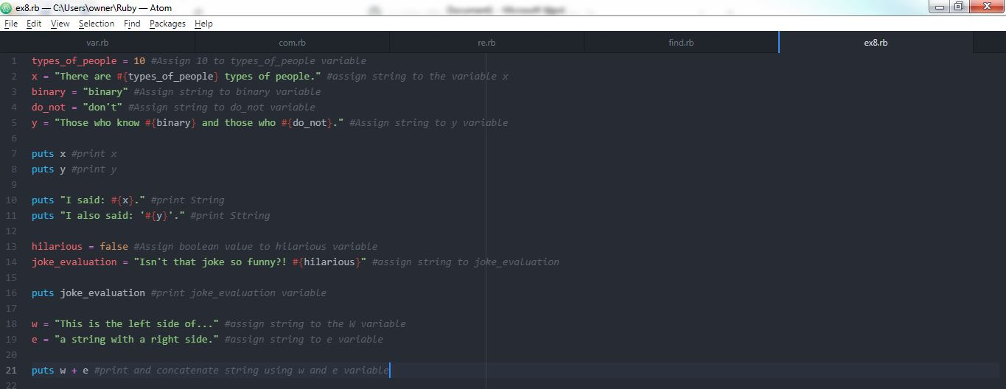
2. Find all the places where a string is put inside a string.

Line 7,8, 10, 11, 16, 21.

**In 6 places, the string is put inside a string.**

1. Are you sure there are only four places? How do you know? Maybe I like lying.

**No, there are six places.**

1. Explain why adding the two strings w and e with + makes a longer string.

**It is a concatenate in ruby. It is merge the two strings. It is not good way to join**.

1. What happens when you change the strings to use ' (single-quote) instead of " (double-quote)? Do they still work? Try to guess why.

